Date | Activities | Who | Resources | Notes
12 Jan | Promise activities  - Photo frames  - Mega block relays | Vicky | Lolly sticks, words of promise printed  Mega blocks with words of promise on | Sarah to coordinate on the evening
13 Jan | Panto at Erith Playhouse
19 Jan | Parachute night | Alex / YLs | Parachute | No Jo
26 Jan | Clickety clack – see picture  Feel the music - dancing  Campfire sing song | Jo | Cardboard shapes, bottle tops, glue, pens  Laptop and music  None | 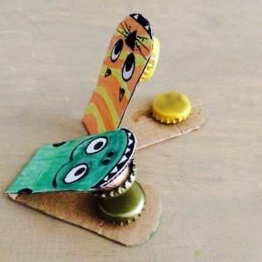
2 Feb | Wild side safari | Sarah | Straws, paper plate templates, pre-cut shapes for animals | 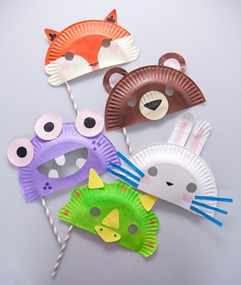
3 Feb | Panto at St Martins
9 Feb | Cardboard Rainbows | Sue | Cardboard, collage materials, pens, glue, string/ribbon | 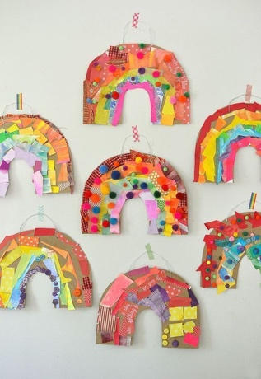
16 Feb | Half Term – Valentine’s Disco
23 Feb | Global night  - Italy  - Africa  - Australia (Fairy bread) | Sarah  Sue  Vicky  Alex  Jo  Lily | TBC  TBC  White bread, butter, sprinkle | Everyone to choose a country and run an activity
1 Mar | National reading month (work on book lover badge, Pts 2 & 3)  Storytelling UMAs  - Splat, Bang, Zoom  - Storytelling sticks  - Story puzzles  Book lover badge  - Bring their favourite book(share the review)  - Puppets of a character from their favourite book | Sarah | None  A6 paper and pens, story  Book covers cut into puzzle pieces -Sarah C  None  Puppet materials, glue etc -Debbie | Ask Sarah C for puzzle pieces  Ask Debbie for yoghurt pots and scrap collage
8 Mar | Growing up wild… in the spring wild  - Planting sunflowers  - Fingerprint cards  - Shadow tag | Debbie | Plant pots, soil, seeds, sharpies  Ink pads, baby wipes, card templates  None
15-17 Mar | Sleepover weekend
22 Mar | Cardboard caving, promises and sponsored stay out | ALL | Cardboard boxes, masking tape  Promise/awards stuff

