Week 1 - Pirates
Hi everyone! Today at Rainbows we are going to become pirates and go on an adventure! First, we need to think about wearing the right clothes.
Live Smart Stage 1 – Catwalk Craze (finish off with creating a pirate hat and eye patch.
Pirates often have parrots for pets. Let’s make our own.
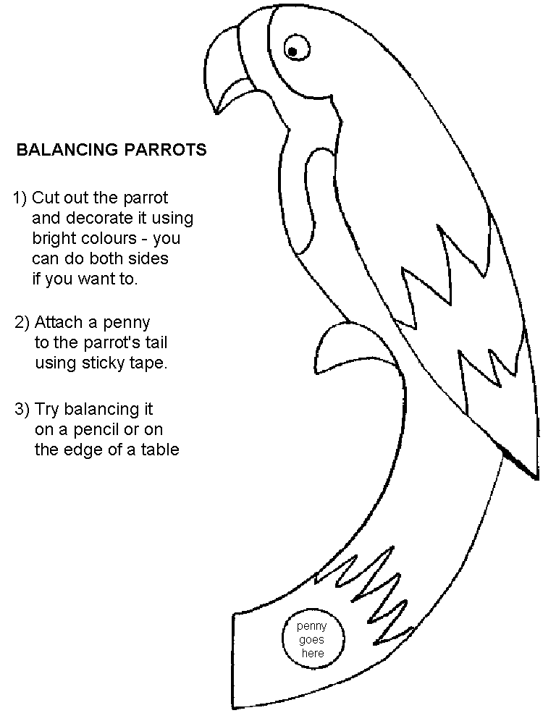
Live Smart Stage 1 - Safety superheroes. We’ll need to know how to be safe. Together we’re going to make some rules about how to be safe on our journey. (Show pictures of dangers and discuss. If time, create a mini ‘adventure world’ for children to spot dangers in.)

Week 2 - Preparations
Last week, we became pirates and learned how to be safe. A long time ago, pirates used to get a disease called scurvy because they didn’t eat enough fruit. Let’s make sure we don’t have that problem. Here are some tokens you can use to buy the fruit that you need.
Live Smart Stage 2 – Feeling Fruity/Combine with Fruit Shop UMA (SF)
(girls to use tokens to buy fruit to make fruit boats).
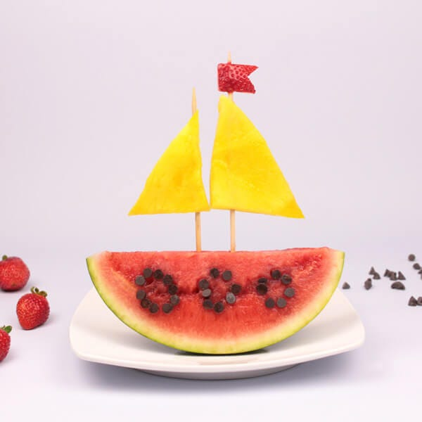
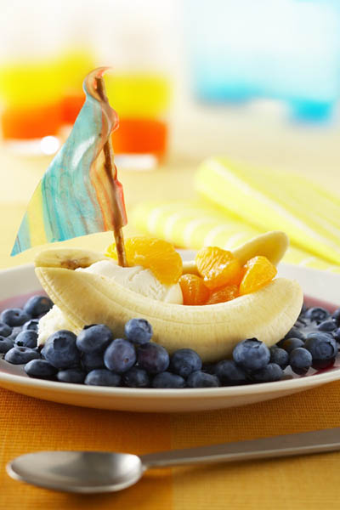
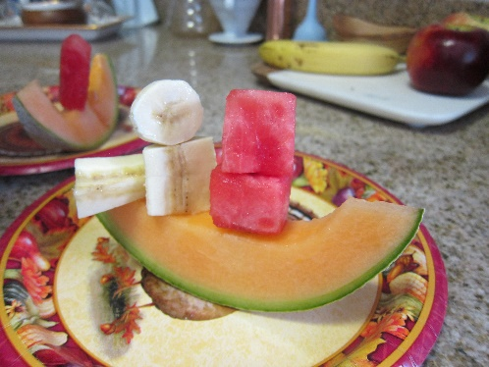

Now we need to get our boat ready. I’ve managed to get us some boats but, unfortunately, I think they might need some fixing.
Live Smart Stage 2 – Stick It, Fix it.
If time, Shape of you UMA (EM). Ask girls to create a giant pirate ship as a group.

Week 3 – Set Sail
We’re all ready to set sail! Let’s get together and row our boat! (Sit together in groups like on a boat and row). Who is in charge? That’s right. The captain! We better do what he tells us.
Captains Orders UMA
There are lots of ropes and sails on this boat and one has become lose. Let’s find out how to fix it.
Plait a Mat UMA
Tied Up in Knots UMA - https://www.youtube.com/watch?v=o_wuRz3TSno Just practise tying shoe laces rather than do the various stations.
If time - Chattering Teeth. Pirates didn’t always manage to brush their teeth when they were at sea so they might not have any. Let’s play a funny game where we don’t show our teeth.

Week 4 – At sea
Last week, we boarded our boat and now we are out at sea. What can we do to pass the time? Let’s have a relaxing story.
The Big Blue Whale UMA
It’s getting dark. I wonder what it will be like in the dark.
It’s Dark Outside UMA
How will we know where are going? What could we use to help us?
Stars in Your Eyes UMA
If time, Fish are Friends UMA.

Week 5 – Overboard
I can see dark clouds on the horizon. I think we might be in for a storm.
It’s Sounding Stormy UMA
Oh no! That storm was really bad and now we’ve gone overboard. Let’s see what we can see in the water while we are here!
Coral Reef City UMA
I think I can see a shark in the water! Oh no!
Fish are Friends UMA
I think we finally lost that shark but we better try and swim to safety!
Swimming to Safety UMA
Here we are then, washed up on a desert island. I wonder how we will survive!
Secrets of Survival UMA
Hot and Cold UMA

Week 6 – Treasure
Look over there! An island. Perhaps it has treasure on it. But, oh no! There is another group of pirates who are trying to get our treasure. Quick. Let’s try and get the treasure first.
Tricky Treasure Island UMA
We got the treasure! Let’s have a look at it together.
Live Smart Stage 1 – Marvellous Money/Know Your Coins UMA/Coin Chain Challenge UMA
It’s important to keep our money safe. Let’s think a bit more about that.
Safety Comes First UMA
We could go and spend our treasure at a local market. I wonder what we can buy.
Higher or Lower UMA
Wow! What an amazing adventure we have had being pirates! Here is a badge to help us to remember what we’ve learned.

