Rainbows Space
Week 1: UMA: Astronaut Academy (HA 30), Read all about it (TA 20).
I’ve been reading a newspaper this morning and I read an interesting story about a dragon going in to space. Let’s find out more. Complete Read All About It UMA
I’d love to go travelling through space. Shall we go and find out what it is like? What will we need? Discuss – e.g. a space helmet/a rocket ship etc.
Complete Astronaut Academy UMA.
Make Astronaut Helmets - https://www.tiktok.com/@twinkl_resources/video/7229232210400890139
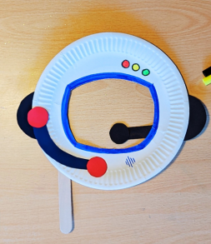
Well done everyone, we can continue our journey through space next week.
Week 2: UMA: Stop that leak (SFMF 20), Blast Off (HA 45)
Last week, we learned how to be an astronaut. This week hopefully we’ll be on our way.
What do we need to get in to space? A spaceship. What do we say when a rocket goes in to space? Blast off! Let’s have a go at making a rocket blast off in to space.
Complete Blast Off UMA - https://buggyandbuddy.com/straw-rockets-with-free-rocket-template/
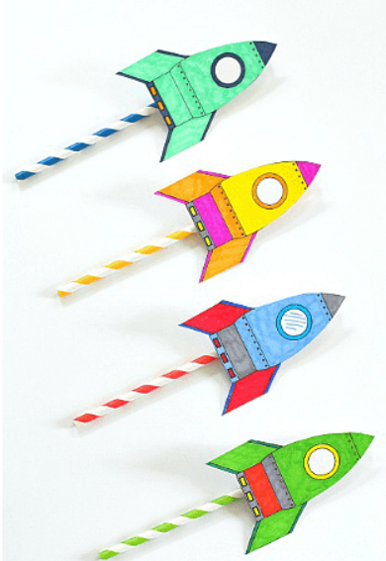
We’re off! Let’s think about what can we see. Oh no, listen! Can you hear that noise? Our spaceship has been caught in a meteor shower and sprung a leak! We better fix it, quick, else we’ll never be able to finish our trip.
Complete Stop that leak UMA
Week 3: UMA: Spinning in Space (HA 30), Moonwalk (HA 30).
Last week, we set off in to space. What can you see as you look around? Look, I can see the moon.
Uh-oh, our spaceship computer has accidentally been locked, and we need the password. What was it again? Nobody knows? OK, NASA says they wrote it on different bits of paper, so we just need to find them and put them together. But they’re stuck to the outside of our spaceship! Why did they think that was a good idea?! We’re going to have to go on a spacewalk!
Complete Moonwalk UMA
The moon seems to be moving. Let’s find out why!
Complete Spinning in Space UMA.
https://www.bakerross.co.uk/craft-ideas/kids/sun-earth-and-moon-orbit-model/ 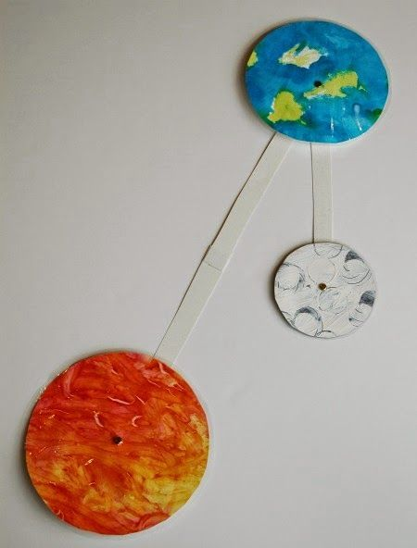
I wonder where we will go next week!

Week 4: UMA: Space Safari (HA 45)
Now we’re moving quickly again, we can take a closer look at all these planets – there are 8 of them, and they’re all really different!
Complete Space safari UMA - http://www.busybeekidscrafts.com/Orbiting-Planets.html
We learned lots about all those planets. Which one shall we visit next week?
Week 5: UMA: What is that? (SFMS 45), Monster Mash (EM 45)
We’ve been travelling through space and we’ve fixed a leak and completed a moon walk. Now we’re all set to land our spaceship on X planet– let’s hope the landing isn’t too bumpy! Will there be aliens for us to meet? We’ve landed! Now we can get out and explore! Euww, look, there’s alien slime all around us…
Complete What Is That? UMA
Oh my goodness, what sort of aliens do you think leaves slime behind them like this? What do you think they look like? Complete Monster Mash UMA
(Discussion about the model aliens – are they friendly, what questions would they ask you, etc.)
You were amazing space explorers! Here’s a badge to put on your uniforms to remind you of our adventures!

